FOODLOOP: AI-POWERED HYPERLOCAL APPLICATION FOR OPTIMIZED FOOD REDISTRIBUTION AND COMMUNITY HUNGER MITIGATION

## PROJECT WORK PHASE1(REVIEW2)

***Submitted by***

# PRADEEPRAJ P 212222240073

***in partial fulfilment for the award of the degree of***

# BACHELOR OF TECHNOLOGY

***in***

**ARTIFICIAL INTELLIGENCE AND MACHINE LEARNING**



**SAVEETHA ENGINEERING COLLEGE, THANDALAM**

**An Autonomous Institution Affiliated to**

# ANNA UNIVERSITY - CHENNAI 600 025

NOVEMBER 2025



**INDEX**

|  |  |  |
| --- | --- | --- |
| **EX. NO** | **PROGRAM** | **PAGE NO.** |
| 01 | **Executive Summary** | 3 |
| 02 | **Targeted Customer Segment** | 4 |
| 03 | **Targeted Pain Points** | 6 |
| 04 | **Solution 1 – AI-Driven Surplus Food Identification and Redistribution** | 8 |
| 05 | **Solution 2 – Hyperlocal Availability Dashboard & Instant Access System** | 10 |
| 06 | **Best Solution – Integrated Hyperlocal AI Redistribution System** | 12 |
| 07 | **Value Proposition** | 17 |
| 08 | **Cost Involved** | 18 |
| 09 | **Startup Investment System** | 20 |
| 10 | **Technology Involved** | 22 |
| 11 | **Conclusion** | 24 |

FoodLoop: AI-Driven Hyperlocal Application for Optimized Food Redistribution and Community Hunger Mitigation

# 1: Executive Summary

The Business Model for FoodLoop: AI-Driven Hyperlocal Application for Optimized Food Redistribution and Community Hunger Mitigation presents an innovative and socially impactful approach to minimizing food wastage while addressing hunger within local communities. This model focuses on creating a seamless connection between surplus food donors such as restaurants, grocery outlets, event organizers, and households, and potential recipients including NGOs, shelters, and food-insecure individuals.

The key strength of the model lies in its integration of AI-driven optimization, hyperlocal geospatial analysis, and real-time mobile connectivity. The system automatically identifies surplus food, predicts demand zones, and matches donors with suitable recipients within the shortest possible distance to ensure freshness and reduce spoilage. Through intelligent automation, FoodLoop eliminates the need for volunteers, manual coordination, and slow traditional donation workflows.

The business model addresses critical challenges such as food wastage, inefficient distribution channels, lack of real-time visibility, and limited access to nutritious meals for vulnerable groups. With its automated matching engine, intuitive user interfaces, and impact analytics, FoodLoop delivers a scalable, efficient, and sustainable solution that supports community welfare and smart city development.

By combining advanced technology with social responsibility, this venture has strong potential for widespread adoption, long-term scalability, and meaningful community transformation

# 2: Targeted Customer Segment Introduction to the Market

The FoodLoop platform caters to a broad range of user groups impacted by food wastage, hunger, and inefficient distribution systems. As communities increasingly seek sustainable and technology-enabled solutions, FoodLoop addresses the rising demand for real-time, hyperlocal food redistribution. The primary target segments include surplus food providers, food relief organizations, and community members in need. These segments represent the foundation of the platform’s operational model, enabling optimized resource utilization and improved accessibility to nutritious food.

# Detailed Breakdown of Segments

1. **Restaurants and Food Reatilers:**

Restaurants, bakeries, hotels, and grocery stores frequently generate surplus edible food due to unpredictable customer demand. Without proper redistribution channels, this food often goes to waste. FoodLoop offers these businesses a streamlined method to donate surplus food while contributing to corporate social responsibility (CSR) goals.

# Event Organizers and Households:

Large events, catering services, and households also generate significant quantities of surplus food. These groups lack efficient systems to distribute leftovers quickly. FoodLoop provides a simple, mobile-based platform that enables timely and responsible food sharing.

# NGOs and Shelter Homes:

Organizations serving vulnerable populations often struggle to meet daily food requirements. FoodLoop helps them access reliable surplus food sources, ensuring consistent meal availability and reducing operational burden.

# Food-Insecure Individuals:

Low-income families and individuals facing hunger benefit directly from immediate access to surplus meals, reducing financial strain and improving nutritional intake.

# Market Opportunity

The growing emphasis on sustainability, hunger mitigation, and smart city solutions positions FoodLoop at the forefront of a rapidly expanding market. With increasing food waste and rising hunger rates, the hyperlocal redistribution ecosystem presents significant potential for long-term impact and adoption.

# 3 : Targeted Pain Points

# Overview of Challenges

Food distribution systems in most communities operate with significant inefficiencies, resulting in edible food being discarded while many individuals face hunger daily. The lack of coordinated, technology-driven solutions leads to slow response times, mismatched supply and demand, and uneven distribution opportunities. Traditional donation methods rely heavily on manual communication, volunteer availability, and unpredictable logistics, creating major barriers for both donors and recipients. These issues highlight the need for an intelligent platform capable of handling real-time food availability and ensuring equitable distribution.

# Specific Pain Points by Segment

1. **Restaurants and Food Retailers:**

Many businesses dispose of surplus food due to lack of timely redistribution channels. Manual donation processes, safety concerns, and unpredictable pickup arrangements discourage participation, resulting in unnecessary wastage.

# Event Organizers and Househols:

Events, celebrations, and homes often generate excess cooked food that must be consumed quickly. Without an immediate and accessible system to redistribute it, much of this food ends up in landfills despite being safe to eat

# NGOs and Shelter Homes:

Organizations serving vulnerable communities frequently struggle to meet daily food requirements. They face shortages, inconsistent supply, and challenges in sourcing food quickly during peak demand hours.

# Food-Insecure Individuals:

Low-income families and individuals lack visibility into available surplus food in nearby areas. Dependence on irregular charity services limits access to nutritious meals and forces them to skip meals during shortages.

# Addressing These Pain Points

By focusing on these critical gaps, FoodLoop directly responds to systemic inefficiencies, enabling instant visibility, AI-based matching, and hyperlocal distribution. Addressing these unmet needs strengthens community support, reduces waste, and ensures a more reliable food access ecosystem.

# 4: Solution 1 – AI-Driven Surplus Food Identification and Redistribution What It Entails

Solution 1 introduces an automated, AI-powered system that identifies surplus edible food in real time and redistributes it to nearby recipients with minimal delay. This intelligent approach uses advanced analytics, machine learning models, and hyperlocal monitoring to ensure that fresh, safe, and consumable food reaches those who need it most—before spoilage occurs. The system eliminates dependence on manual coordination by enabling seamless interaction between donors and recipients through an intuitive mobile platform.

# Key Features

1. **AI-Based Surplus Detection:**

The system analyzes donor patterns such as meal prep volumes, peak serving hours, and historical wastage trends to automatically identify when surplus food is likely to be available. This predictive analysis allows FoodLoop to prepare redistribution workflows ahead of time.

# Automated Donor-Recipient Matching:

Using parameters like distance, urgency, food category, and quantity required, the AI engine generates optimal matches. This ensures quick and fair allocation, prioritizing recipients with higher need or limited access.

# Real-Time Freshness Validation:

The platform includes automated checks for preparation time, expiry windows, and food type suitability. Alerts are triggered if food surpasses safe consumption limits.

# Benefits for Each Segment

1. **Restaurants & Retailers:**

Reduces food waste, supports CSR initiatives, and streamlines the donation process without additional labor.

# Event Organizers & Households:

Enables fast redistribution, preventing leftover food from being discarded after gatherings.

# NGOs & Shelters:

Provides a consistent, reliable source of meals without depending on manual outreach.

# Food-Insecure Individuals:

Improves accessibility to nutritious food through quick, hyperlocal redistribution.

# Why It Matters

This solution bridges the gap between oversupply and unmet hunger needs by using intelligent automation. Through real-time analysis and matching, FoodLoop ensures that surplus food is redistributed efficiently, ethically, and sustainably—creating a measurable impact on community welfare.

# 5: Solution 2 – Hyperlocal Availability Dashboard and Instant Access System

Solution 2 introduces a real-time, hyperlocal dashboard that provides instant visibility into surplus food availability within a specific geographical radius. By leveraging geospatial intelligence and mobile-based interaction, this system eliminates guesswork and delays often associated with traditional donation processes. The dashboard allows donors and recipients to view, request, and confirm food availability with ease, creating a transparent and highly efficient redistribution network.

# Technology Involved

1. **Geospatial Mapping:**

The system integrates hyperlocal mapping tools that pinpoint nearby surplus food offerings with high accuracy. Recipients can instantly view available meals, locations, and estimated pickup readiness.

# Real-Time Updates:

Each donation listing is dynamically updated based on donor inputs, expiry windows, and match status. This ensures that only safe and currently available food items are shown on the dashboard.

# AI-Assisted Recommendations:

Artificial intelligence analyzes patterns such as peak surplus times, location density, and previous matching success to recommend the most suitable food opportunities to recipients.

# Customer Benefits

1. **Instant Visibility:**

Recipients no longer rely on periodic announcements or manual communication. The dashboard provides immediate access to surplus food listings within their proximity.

# Convenience:

Both donors and recipients can operate through a user-friendly interface designed for quick navigation, allowing them to confirm matches within seconds.

# Efficiency:

Real-time updates minimize delays and reduce instances of food spoilage by ensuring rapid connection between parties.

# Applications Across Segments

* + **Restaurants & Retailers:** Easily list surplus food and receive instant notifications when matches are found.
  + **Event Organizers & Household:** Quickly share leftover meals with nearby recipients, reducing wastage after gatherings.
  + **NGOs & Shelters:** Access immediate surplus food opportunities during peak service hours.
  + **Food-Insecure Individuals:** Locate available meals within walking distance without any dependency on third parties.

# Why It Stands Out

This solution transforms food redistribution into a transparent, real-time ecosystem. By making surplus food instantly discoverable and actionable, the hyperlocal dashboard significantly improves the speed and reliability of community hunger mitigation efforts

# 6: Best Solution – Integrated Hyperlocal AI Redistribution System Why Combine Solutions?

The combination of AI-driven surplus food identification and a hyperlocal availability dashboard forms the core of the FoodLoop ecosystem. By integrating both solutions, the system provides unmatched efficiency, accuracy, and speed in managing surplus food redistribution. This unified model ensures that surplus food is not only detected intelligently but also reaches the nearest and most deserving recipients through a transparent and automated workflow. Together, these innovations eliminate the delays and inconsistencies found in manual donation processes, making FoodLoop a highly scalable and community-focused solution.

# Value Proposition

1. **End-to-End Automation:**

The integrated platform manages the entire redistribution cycle—from surplus detection to recipient matching and completion—without any manual intervention or volunteer dependency.

# Hyperlocal Precision:

By combining AI insights with real-time geospatial mapping, the system ensures that every donation is matched within the shortest radius, preserving food quality and minimizing logistical challenges.

# Reliable Recipient Access:

NGOs, shelters, and individuals gain immediate visibility into local surplus food, improving accessibility and reducing uncertainty about meal availability.

# Enhanced Customer Experience:

The integration creates a seamless user journey where donors can effortlessly list surplus food, and recipients can instantly view, request, and accept meals without delays. Automated notifications, freshness checks, and transparency ensure a smooth and trustworthy experience for all users involved..

# Long-Term Relevance:

The blended system is designed to evolve with increasing community needs and technological advancements. As food waste regulations tighten and smart city initiatives expand, FoodLoop’s integrated model becomes a sustainable, future-ready solution that can support large-scale adoption.

# 7: Manufacturing Process Breakdown for Foodloop: Overview

The implementation and deployment of FoodLoop involves a combination of software engineering, data engineering, field pilot operations, and stakeholder onboarding. This process ensures that the platform is robust, secure, food-safe, and optimized for real-world hyperlocal redistribution. The breakdown below describes each phase from planning to production roll-out and quality assurance.

# Detailed Steps

1. **Requirement Gathering & Stakeholder Mapping:** Conduct detailed consultations with restaurants, grocery stores, NGOs, shelters, municipal authorities, and community representatives to collect functional and non-functional requirements. Map stakeholder roles, data sharing policies, liability clauses, and food-safety responsibilities to form clear operating procedures.

# System Design & Architecture: Design a modular architecture comprising mobile frontends, backend services, AI optimization engine, geospatial matching layer, notification systems, and analytics dashboards. Define APIs, database schemas, security layers (encryption, RBAC), and failover strategies to ensure high availability and data integrity.

# Technology Procurement & Environment Setup: Provision cloud infrastructure, geolocation APIs, push-notification services, and CI/CD pipelines. Set up staging and production environments, container orchestration (e.g., Docker/Kubernetes), and monitoring tools for logs, performance, and security auditing.

# Data Collection & Annotation: Data Collection & Annotation: Collect initial datasets for model training: historical donation patterns, donor schedules, recipient demand profiles, food perishability parameters, and geospatial mobility data. Annotate data for supervised learning tasks such as demand prediction and perishability classification.

# Machine Learning Model Development: Develop and train models for demand forecasting, and donor–recipient matching. Use cross-validation, hyperparameter tuning, and fairness assessments to ensure robust performance across diverse neighborhoods and user groups.

# Web App & Backend Development: Implement the donor and recipient web interfaces, secure authentication, listing workflows, acceptance flows, and status-tracking screens. Build backend microservices for matching, notifications, data persistence, and analytics. Integrate automated freshness validation and consent capture flows.

# Integration & API Testing: Perform end-to-end tests across geospatial services, notification providers, and payment or verification gateways (if applicable). Validate API contracts, error handling, retry logic, and edge cases (cancellations, late pickups, expired listings).

# Food-Safety SOPs & Legal Compliance: Create Standard Operating Procedures for handling, packaging, pickup windows, and liability waivers. Ensure compliance with local food-safety regulations, data privacy laws, and municipal donation guidelines. Provide onboarding materials and digital consent forms for donors and recipients.

# Pilot Deployment & Field Trails: Run controlled pilots in selected neighborhoods with partner restaurants and NGOs. Monitor real-world metrics—match success rate, time-to-delivery, food acceptance ratio, and user feedback. Iterate models and UX based on pilot learnings.

# Partner Onboarding & Training: Train NGO staff and donor personnel on the app workflows, hygiene protocols, and escalation processes. Offer quick-start guides, in-app tutorials, and dedicated support channels during initial operations.

# Monitoring, Logging & Continuous Improvement: Deploy monitoring dashboards for system health, algorithm drift, and impact metrics. Implement automated alerts for model degradation, failed matches, or unusual activity. Schedule periodic retraining of ML models with fresh data and community-sourced feedback.

# Scale-Out & Citywide Rollout: Gradually expand geographic coverage by adding more donors and recipient nodes, optimizing compute and storage capacity. Engage municipal partners for wider adoption and integrate with local welfare programs where feasible.

# Technical Highlights

* + **Modular, API-first architecture** enabling rapid integration with municipal services and third-party partners.
  + **Secure data handling** with encryption at rest/in transit and role-based access control**.**
  + **Automated freshness checks** combining time-to-prep, storage conditions, and type-based perishability windows.
  + **Feedback loop for** **ML** where acceptance/ rejection signals continually improve matching quality.

# Quality and Safety Checks

* + Food eligibility validations before listing (time-since-preparation checks and donor-declared storage details).
  + Periodic audits of partner practices and mobile-captured photos for verification.
  + Emergency escalation workflows for disputed pickups or food-safety concern.

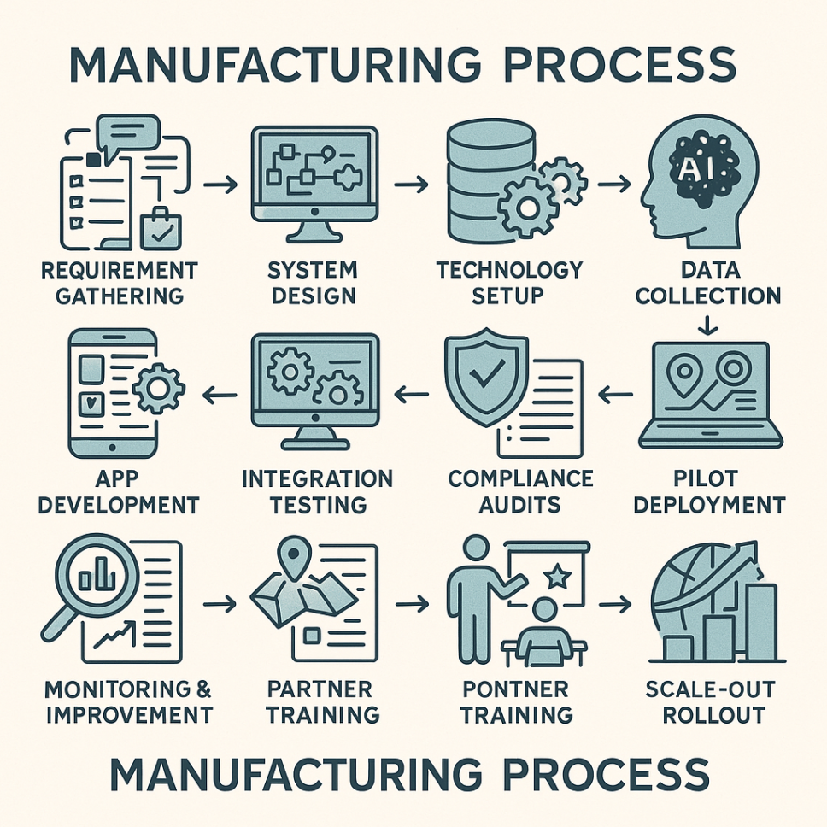

**8: Value Proposition**

**Key Features of the Business Model**

1. **Personalized and Reliable Access to Food:**

The platform offers real-time visibility into available surplus food through an intuitive dashboard, ensuring that NGOs, shelters, and individuals always have direct and reliable access to meals in their locality. The AI-powered matching system ensures every request is paired with an appropriate donor, enhancing both accuracy and accessibility.

# Enhanced Efficiency and Reduced Wastage:

FoodLoop minimizes delays and streamlines the redistribution process through end-to-end automation. By identifying surplus food instantly and matching it to nearby recipients, the system significantly reduces spoilage and supports sustainable consumption practices.

# Streamlined User Experience:

The platform simplifies interactions for all user groups—donors can upload surplus food easily, and recipients can request meals instantly through a clean, user-friendly mobile interface. Real-time notifications and freshness validation ensure a smooth, transparent, and trustworthy experience.

# Sustainability and Social Impact:

By preventing edible food from being discarded, FoodLoop contributes to waste reduction, carbon emission mitigation, and improved community well-being. The model aligns with SDG goals such as zero hunger, responsible consumption, and sustainable cities.

# Versatility Across Segments:

The platform supports a wide range of users, restaurants, households, event organizers, NGOs, and food-insecure individuals, making it adaptable and scalable across diverse communities and city ecosystems.

# 9: Costs Involved Major Cost Categories

1. **Research and Development (R&D):**
   * Initial R&D focuses on developing the AI optimization engine, surplus prediction models, hyperlocal mapping algorithms, and user interface prototypes. This phase includes testing automation workflows, safety validation for food handling, and pilot-level deployment. Estimated cost: **₹2–3 Lakhs**.

# Technology Infrastructure:

* + Key technology investments include mobile application development, backend infrastructure, cloud database services, security protocols, and geospatial API integrations. These ensure real-time updates, secure data management, and efficient processing. Estimated cost: **₹3–4 Lakhs**.

# Platform Deployment and Testing:

* + This includes beta testing, scalability assessments, usability tests, performance monitoring, and fine-tuning the recommendation algorithms. Costs also cover initial server scaling and app store deployment fees. Estimated cost: **₹1–1.5 Lakhs**.

# Marketing and Outreach:

* + To attract donors, NGOs, households, and food-insecure individuals, targeted marketing campaigns will be conducted. This includes digital marketing, community outreach programs, and awareness drives. Estimated cost: **₹50,000–₹1 Lakh** .

1. **Operational and Maintenance Costs:**

* These include cloud hosting, continuous monitoring, algorithm updates, bug fixes, and user support. Preserving system reliability requires consistent operational investment. Estimated annual cost: **₹1–1.5 Lakhs**.

# Total Estimated Cost

The initial project investment for FoodLoop is projected to be **₹8–10 Lakhs**, ensuring robust development, testing, and launch readiness. Additional yearly operational costs support scalability and long-term sustainability.

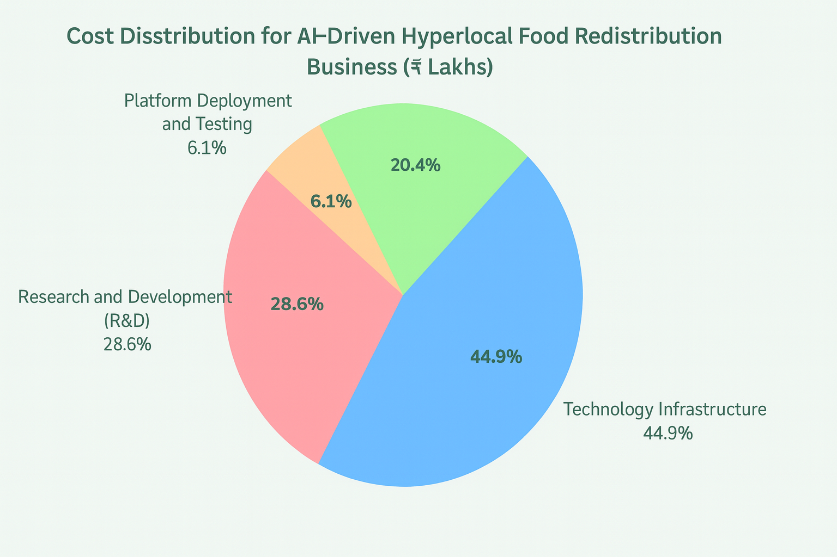

# 10: Startup Investment

**Funding Strategy**

Launching FoodLoop requires a strong and diversified funding strategy to ensure smooth development, deployment, and long-term sustainability. The goal is to secure financial support that aligns with the platform’s technological vision, operational needs, and community impact objectives. A combination of internal and external funding methods will be used to build a robust financial base for the startup.

# Sources of Funding:

* + **Self-Funding:** Founders can initiate the project through personal investment, which provides full control during the early development phases. This ensures rapid decision-making, flexibility in prototype refinement, and early-stage stability before seeking external funds.
  + **Government Grants:** arious state and national-level grants supporting sustainability, waste reduction, and social welfare initiatives can significantly reduce early-stage expenses. Programs focusing on digital innovation, smart city development, and food waste management may provide substantial financial support.
  + **Angel Investors:** Early-stage investors interested in social impact technology, community welfare, and AI-driven solutions can provide capital as well as mentorship. Their involvement helps accelerate development and improves strategic decision-making.
  + **Venture Capital:** Once the model is validated and initial traction is established, venture capital funding helps scale the system to multiple cities. VC firms offer large-scale investment, networking opportunities, and business expertise for rapid expansion.

# Allocation of Funds:

* + **Technology Development (40%):** AI model training, mobile app development, database architecture, and geospatial systems..
  + **Infrastructure & Deployment (35%):** Cloud hosting, servers, cybersecurity, app store releases, and system testing environments.
  + **Marketing & Community Outreach(15%):** User acquisition campaigns, donor onboarding, and awareness drives with NGOs and communities.
  + **Operations & Support (10%):** Platform maintenance, monitoring, staffing, and customer support.

# Justification for Investment

FoodLoop serves a critical need in society by simultaneously addressing food wastage and hunger. As smart city initiatives expand and sustainability becomes a priority, the demand for intelligent food redistribution systems is expected to grow rapidly. With strong technological foundations, community relevance, and scalability, the startup offers high-impact potential for investors seeking both financial returns and meaningful social contributions.

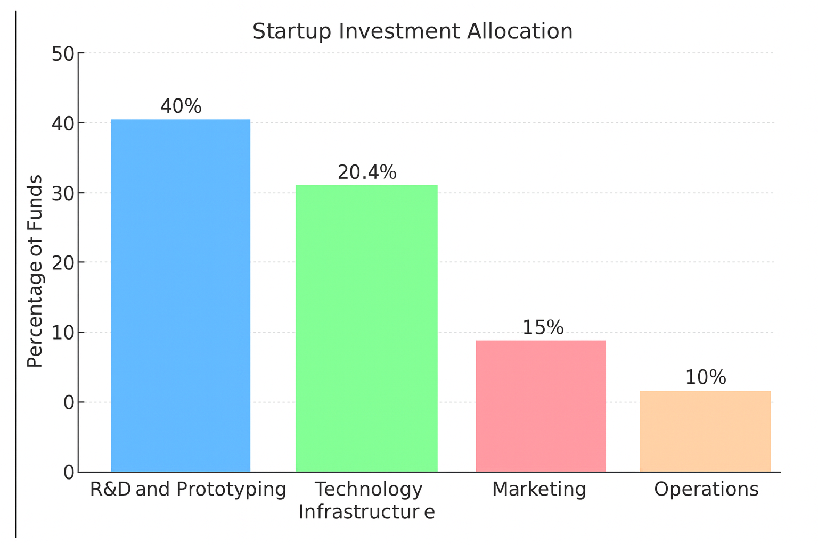

# 11: Technology Involved

**Overview**

Technology forms the backbone of the FoodLoop system, enabling fast, reliable, and intelligent redistribution of surplus food across hyperlocal communities. The integration of AI, geospatial computation, mobile connectivity, and secure data handling transforms traditional food donation models into an automated and scalable solution. These technologies work together to ensure the platform operates efficiently, safely, and with real-time precision. The core Technologies are :

# Artificial Intelligence (AI) & Machine Learning:

AI models analyze food donation patterns, predict demand zones, classify surplus food based on type and perishability, and perform automated donor–recipient matching. Machine learning algorithms continuously improve accuracy by learning from historical data and usage patterns.

# Geospatial Mapping & Hyperlocal Positioning:

Using advanced geolocation services, the platform identifies nearby donors and recipients, calculates optimal routes, and ensures minimum time-to-delivery. This supports precise redistribution within tight time windows to avoid food spoilage.

# Mobile Application Framework:

The system utilizes a robust mobile-based interface for both donors and recipients, enabling real-time listing, request handling, notifications, and tracking. The app ensures accessibility, ease of use, and immediate user engagement.

# Real-Time Notification System:

Push notifications and in-app alerts keep users informed about matches, availability, acceptance status, and completion updates. This maintains a seamless communication loop between donors and recipients.

# Database & Data Security Systems:

A secure cloud-based database stores all donor logs, recipient profiles, surplus history, and matching outcomes. Data encryption, authenticated access, and role-based permissions ensure user privacy and compliance with security standards.

# Supporting Elements : 6. Automated Freshness Validation:

Algorithms verify preparation time, expiry duration, and recommended consumption windows to ensure only safe and consumable food is listed.

**7.Impact AnaImpact Analytics & Reporting**

A built-in analytics engine tracks meals distributed, food waste prevented, environmental benefits, and community impact. This data supports reporting for stakeholders, NGOs, and local authorities.

**Why This Technology Matters**

The integration of these technologies transforms FoodLoop into an intelligent ecosystem capable of addressing hunger and food waste at scale. By ensuring real-time precision, automation, and transparency, the platform significantly enhances the efficiency and reliability of food redistribution across communities.

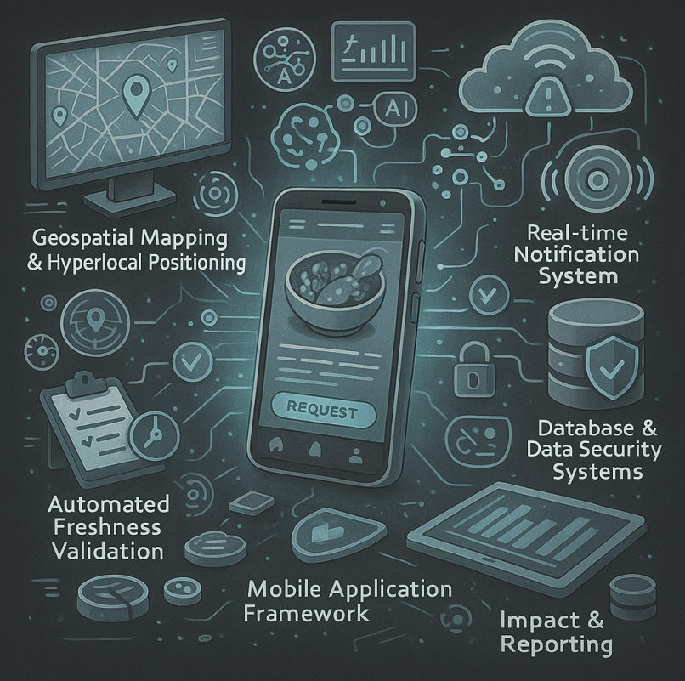

# 12. Conclusion

The Business Model for **FoodLoop: AI-Driven Hyperlocal Application for Optimized Food Redistribution** represents a transformative solution that addresses two of society’s most pressing challenges—food wastage and hunger. By leveraging advanced technologies such as artificial intelligence, geospatial analytics, and real-time communication systems, FoodLoop provides a seamless and efficient approach to connecting surplus food donors with recipients in need. This model replaces traditional, slow, and volunteer-dependent processes with an automated, scalable ecosystem that ensures timely access to nutritious food while minimizing spoilage.

With its emphasis on automation, sustainability, and community welfare, FoodLoop has the potential to significantly enhance food accessibility across diverse segments, including NGOs, shelters, households, and individuals experiencing food insecurity. The platform not only simplifies the redistribution process but also contributes to environmental conservation by reducing the volume of edible food entering landfills.

Incorporating intelligent matching, hyperlocal visibility, and transparent impact tracking, FoodLoop positions itself as a future-ready solution aligned with emerging smart city initiatives and social responsibility goals. As technological adoption grows and awareness of food waste increases, this model has the capacity to scale across regions and create long-term societal impacts. Through innovation and collaboration, FoodLoop stands poised to redefine how communities manage surplus food and support sustainable living.

